LANDSCAPE GROUP: HERITAGE

1. National Planning Policy Framework: para. 11 (b) sub section 6
Strategic policies should, as a minimum, provide for objectively assessed needs for housing and other uses, as well as any needs that cannot be met within neighbouring areas UNLESS:

(i) the application of policies in this framework that protect areas or assets of particular importance provides a strong reason for restricting the overall scale, type or distribution of development in the plan area (6)
(6) The policies referred to are those in this Framework (rather than those in development plans) relate to:…land designated as Green Belt...irreplaceable habitats…designated heritage assets…; and areas at risk of flooding….

Para. 184 and 190
Heritage assets range from sites and buildings of local historic value to those of highest significance…. these assets are an irreplaceable resource, and should be conserved in a manner appropriate to their significance, so they can be enjoyed for their contribution to the quality of life of existing and future generations.

Local Planning Authorities should identify and assess the particular significance of any heritage asset that may be affected by a proposal (including any proposal affecting the setting of a heritage asset) taking account of the available evidence and any necessary expertise ….

NOTE: Para 11, note 6 implies any development on greenbelt or around heritage assets, and flood plains, is fundamental to consideration of a development. TWBC must therefore evidence outweighing (and convincing) factors to overcome this, including properly assessing the impact on the setting of those heritage assets.

NOTE: Heritage assets are defined as listed buildings, but extend to other historical property and, potentially, landscape. The addresses of all listed properties in the area can be found using the Historic England website:
https://historicengland.org.uk/listing/the-list/
The effect of the proposals on the setting of heritage assets in both sites is a consideration a Council planner should take into account.

2. TWBC Landscape Character Assessment Supplementary Planning Document 2017 (LUC)
Character Area 13: Paddock Wood/Five Oak Green Low Weald Farmland

Capel and Tudeley… are small hamlets, with traditional buildings clustered around the Grade I Listed sandstone churches. The stained-glass windows at Tudeley’s All Saints Church were designed by the early modernist artist Marc Chagall. The hamlets have strong vernacular character and focal points with frequent glimpsed views to the surrounding agricultural landscape.

A variety of building styles ranging from groups of oasts, which are highly visible, to more modern suburban houses and bungalows.

There are a large number of historic oast houses which are frequently visible throughout the landscape. Many are associated with small hamlet groupings, with many surviving from the medieval period, 17th and 18th centuries. They are very distinctive features within this open landscape. (Note: Many Oast houses are 19th century, although TWBC’s document states earlier as quoted above).

There are numerous traditional historic buildings typical of the Weald, including timber framed houses and farmsteads….

Open views across this intensively farmed landscape are frequently punctuated by the cowls of clustered groups of oast houses and extensive farm building complexes. The Greensand Ridge to the north provides a distinctive skyline, whilst the High Weald to the south provides wooded enclosure.

NOTE: Whilst the development will impact on the Tudeley landscape, and the views to the Ridge and the High Weald, there is likely to be less impact for East Capel, which may be shielded from the Castle Hill viewpoint by Paddock Wood.

3. Kent Farmstead Assessment Guidance 2016

Low Weald and High Weald
• This area has the highest percentage of farmsteads with less than 50% change since c.1900 in the county.
• High density of 17th century and earlier timber- framed buildings.
• Many small loose courtyard plans survive with minimal change.
• Dispersed plan types are particularly characteristic of the Weald and sites with little change are particularly significant.
• The area, especially the High Weald, stands out in a national context for its very high densities of historic farmsteads dating from the medieval period and which were established within a landscape largely cleared from woodland.
• This combination of medieval farmsteads and landscapes is highly significant, and it is heightened by the high survival of pre-1750 timber-framed buildings.

Para 1.21 Significance is a word to summarise what is important about a building or place, whether it is designated as an historic asset or not…..farmsteads can be considered on 2 levels:
- significance as a traditional farmstead in its own setting
- local and national significance

NOTE: There may be listed and unlisted buildings within an historic farmstead, but the unlisted buildings will be treated by the Planning Department is the same way. This would increase the number of heritage assets significantly – see 5. Listed Buildings – page 4.

4. DECISIONS
a. Decision 12th April 2019: Appeal Ref: APP/A1720/W/18/3199119: Land east of Posbrook Lane, Titchfield, Fareham, Hampshire PO14 4EZ
- The development proposed is described as an ‘Outline Planning Application for Scout Hut, up to 150 Dwellings, Community Garden, associated landscaping, amenity areas and means of access from Posbrook Lane in addition to the provision of 58,000 square metres of community green space’.
- The appeal is made by Foreman Homes Ltd against Fareham Borough Council.
The appeal was DISMISSED, the main issues being:
- The effect of the proposed development on the character and appearance of the area, including having regard to whether or not the site is a valued landscape and the effect on the strategic gap;
- The effect of the proposed development on the setting of ‘Great Posbrook’ and the ‘Southern barn at Great Posbrook Farm’ Grade II* listed buildings;
- The effect of the proposed development on Best and Most Versatile Agricultural Land (BMVAL).

b. TWBC own decision re development at the Poacher & Partridge

NOTE: the Fareham decision does not set precedent, but is an example of what a Council needs to consider. The ‘valued landscape’ is arguable in respect of CA1 at least, in that it will impact not only upon the historic landscape itself, but on the neighbouring AONB.

Apart from the Poacher decision, there are likely to be other TWBC decisions that run contrary to the current proposals, and/or refer to the impact of development on the landscape and setting of historic buildings. Unfortunately, these are probably only going to be found through manual searches of Council records.

5. LISTED BUILDINGS
The proposals for Capel affect 3 key areas; the main Tudeley Garden Village (CA1), East Capel, and Area 447/454 on the boundary of Tonbridge for schools.

Listed buildings within an approximate 1km ‘buffer zone’ of the edge of each development ring are approximately (dependant on exact line drawn) as follows:

- CA1 Grade I 2
    - Grade II* 1
    - Grade II 70

- East Capel Grade I 0
    - Grade II* 1
    - Grade II 45

- Area 447/454 Grade I 0
    - Grade II* 2
    - Grade II 20

In addition, there are 2 GII listed Historic Parks & Gardens and numerous historic farmsteads which, although not listed, TWBC in numerous domestic planning applications seek to preserve following a similar methodology to that which protects listed buildings.
It should also be noted that when these ‘buffer zones’ are drawn on a map (see below) they bisect, meaning there is little ‘buffer’ between the new development sites and that they will, over time, visually merge into 1 sprawl from Tonbridge to Paddock Wood. The impact of development on the buffers are an aspect the Borough Council should consider before agreeing planning permission.

It would also be necessary for a statement of significance and impact to be produced for each of these listed buildings; a costly exercise for developers. The proposals would radically alter the settings of many of these buildings.

Of key significance are the Chagall windows in All Saints’ Church, Tudeley. The impact of change in light through these windows by encroaching development could significantly alter their impact. These windows are a unique national, and global asset. Chagall was commissioned to design one commemorative window in the church, however, he considered the light and setting so perfect he designed and made every window; All Saints’ is the only church in the world to have a complete set of Chagall windows.

Listed buildings are “irreplaceable”, any harm or loss should require clear and convincing justification.

6. MAPS

Proposed development areas with 1km buffer, and listed buildings (triangles)

  - CA1 shown to left with Capel East site shown to the right.
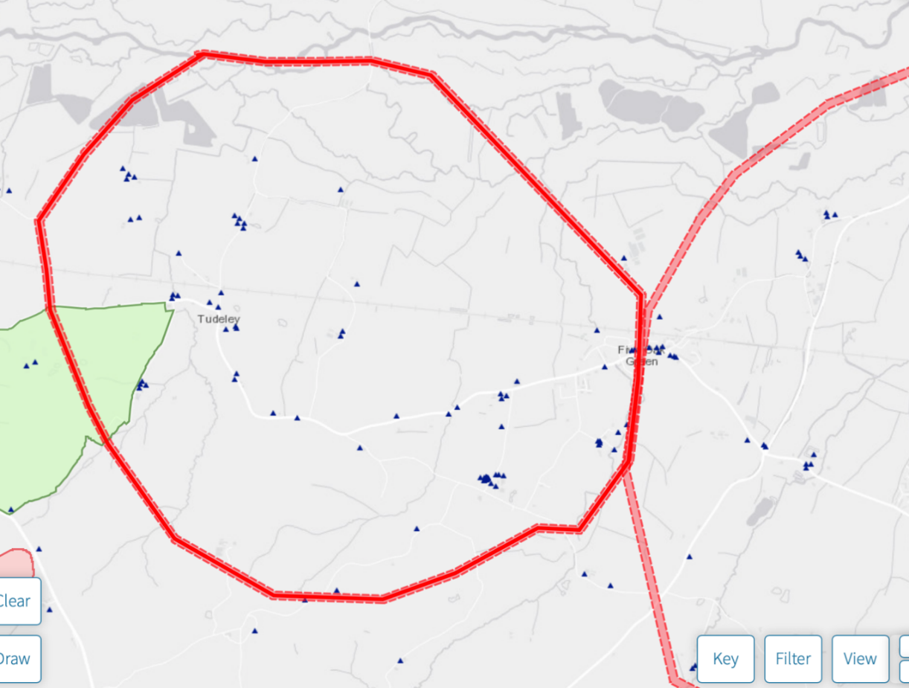

b. East Capel
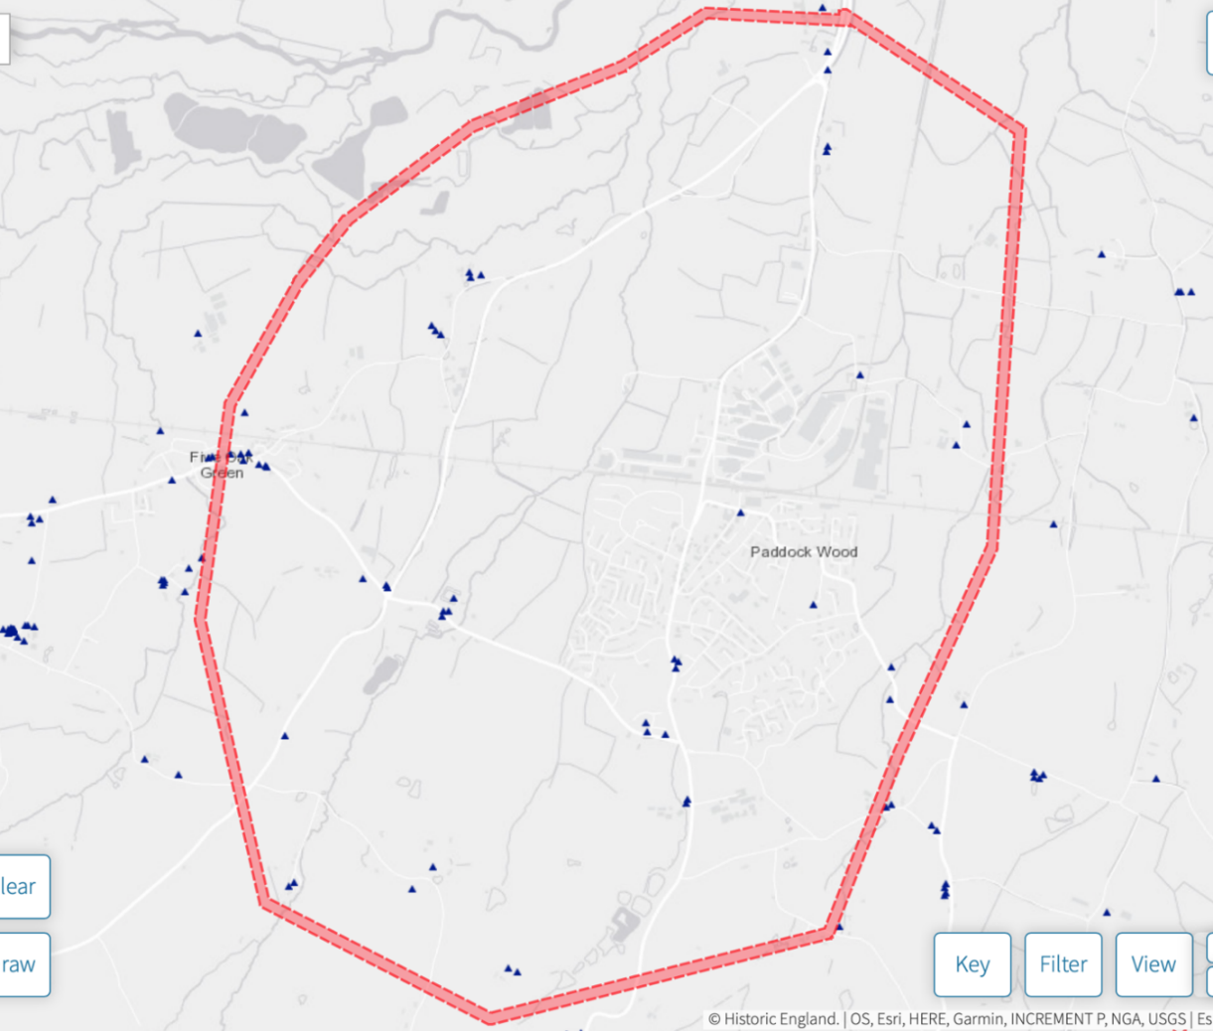

c. Proposed School site



